(Semester II)

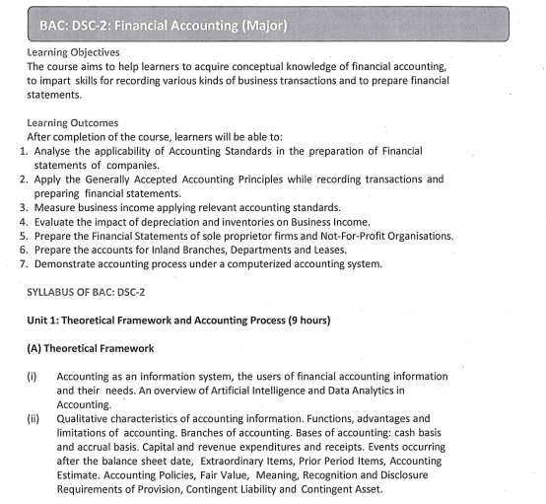

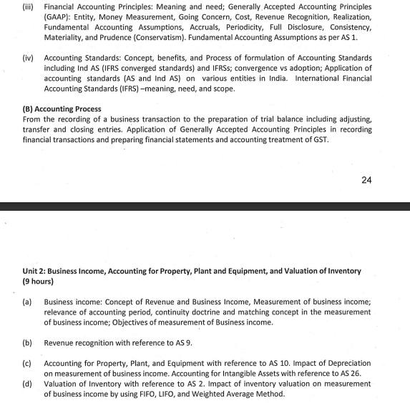
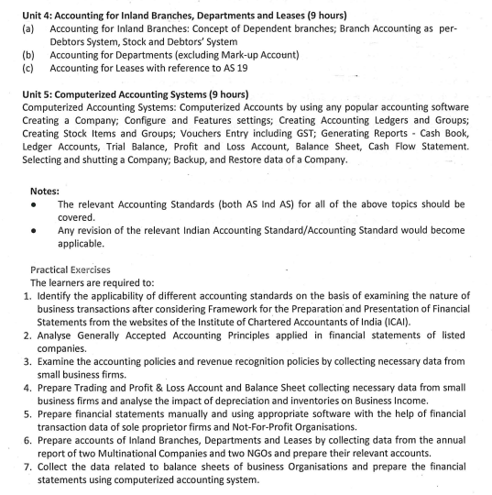
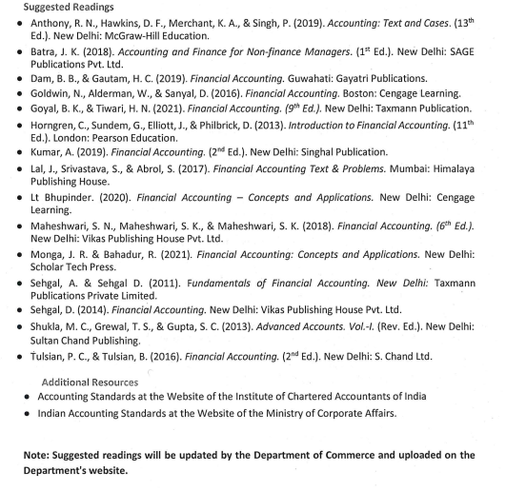

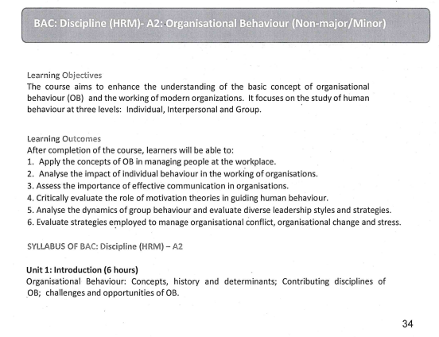
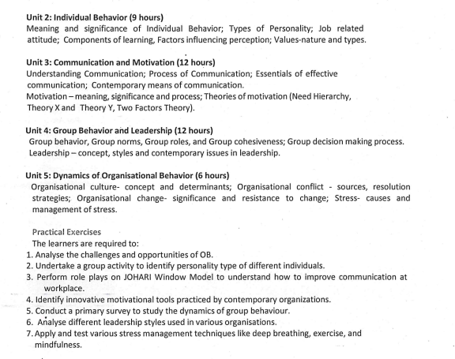
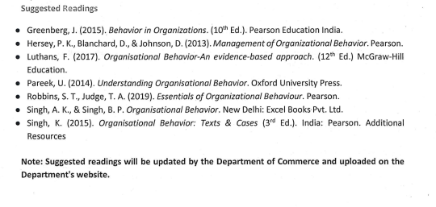

(Semester IV)

- BAC: DSC-4: Principles of Management (Major)

Learning Objectives
The course aims to equip learners with essential management related knowledge and skills and
their applicability in the real world.

Learning Outcomes
After completion of the course, learners will be able to:
1. Discuss evolution of management and its significance.
2. Analyse applicability of managerial functions.
3. Assess the significance of planning and organising in business.
4. Interpret the role of directing in business.
5. Analyse the importance of controlling function and discuss contemporary issues in
management.

SYLLABUS OF BAC: DSC-4
Unit 1: Introduction to Management (9 hours)
Principles of management - concept, nature and significance; Evolution of Management
thought: Classical (Fayol’s principles of management; Taylor’s scientific management),
Neoclassical (Hawthorne Experiments), Modern approach (Systems Approach; Contingency
Approach).
Unit 2: Functions of Management (7 hours)
Management functions and their relationship- planning, organizing, staffing, directing and
controlling; Coordination - concept, characteristics and importance; Functional areas of
management – an overview.
Unit 3: Planning and Organizing (11 hours)
Planning- meaning, strategic and operations planning; Decision-making- concept, importance
and bounded rationality; Organizing- division of labor & specialization; Organisational
structures- traditional and modern; Factors affecting organisational design.
Unit 4: Directing (11 hours)
BAC: DSC-4: Principles of Management (Major)
210
Concept and theories of Motivation- Maslow’s need hierarchy, Herzber’s two-factor theory,
Theory X&Y; Leadership-meaning and importance, leadership styles, Transactional and
transformational leadership; Communication- meaning and importance.
Unit 5: Controlling and Contemporary Issues in Management (7 hours)
Principles of Controlling, performing controlling function; Management challenges of the 21st
Century; Century; Factors reshaping and redesigning management purpose, performance and
reward perceptions- Internationalization; Digitalization; Entrepreneurship & innovation;
Workplace Diversity

Exercises:
The learners are required to:
1. Assess the applicability of managerial theories in today’s corporate world.
2. Demonstrate the use of managerial functions in organizing an event.
3. Prepare a comparative analysis of organization structures of various companies.
4. Demonstrate various types of leadership styles in form of role play and identify the
motivation techniques used by leaders.
5. Discuss the impact of emerging issues in management.

Suggested Readings:
● Drucker, P. F. (1954). The Practice of management. New York, United States: Harper
& Row.
● Drucker, P. F. (1999). Management challenges for the 21st Century. New York, United
States: HarperCollins Publishers Inc.
● Griffin, R.W. (2011). Management principles and application. Massachusetts, Unites
States: Cengage.
● Koontz, H., & Weihrich, H. (2012). Essentials of management: An international and
leadership perspective. New York, United States: McGraw Hill Publications.
● Kumar, P. (2019). Management: principles and applications. Delhi: JSR Publication
House LLP.
● Laasch, O. (2022). Principles of management. California, United States: Sage
Textbook.
● Mahajan, J.P., Mahajan, A., & Dewan, D. (2017). Management principles and
applications. Uttar Pradesh, India: Vikas Publications.
● Rao, V.S.P. (2017). Management Principles and Applications. Delhi, India: Taxmann
Publications.
● Vasishth, N., & Rajput, N. (2016). Principles of management. Delhi: Kitab Mahal.
Note: Suggested readings will be updated by the Department of Commerce and uploaded
on Department’s website

- BAC: Discipline (HRM) – A4: Performance Management (Non-Major/Minor)

Learning Objectives
The course aims to create fundamental knowledge of performance management, related aspects
like talent management, compensation management, contemporary issues etc. in the
organization through the pedagogy of case discussions and the practices of Indian
Organisations in this context.

Learning Outcomes
After completion of the course, learners will be able to:
1. Identify the process of performance management and performance appraisal.
2. Evaluate different methods of performance management and performance appraisal.
3. Recognise the concept of learning organisation and assess different aspects of
performance-based compensation.
4. Analyse issues in implementation of performance management.
5. Discuss contemporary issues in performance management.

SYLLABUS OF BAC: Discipline (HRM) - A4
BAC: Discipline (HRM) – A4: Performance Management (Non-Major/Minor)
219
Unit 1: Introduction to Performance Management (7 hours)
Meaning, Principles, Objectives, Purpose of Performance Management, Performance
Management vs Performance Appraisal, Performance Management as a Process
Unit 2: Performance Planning and Managing Performance (11 hours)
Developing Performance Planning: Agreement and Action Planning, Methods of managing
performance of all the levels of Management (including labor), Graphics rating scale, Ranking
Methods, Paired Comparison Methods, Forced Distribution Method, Critical Incident Method,
Behaviour ally Anchored Rating Scales, Management By Objective, 360-Degree Performance
Appraisal, Performance Feedback & Counselling.
Unit 3: Learning Organisation and Performance Based Compensation (9 hours)
Concept-Peter Senge Model, Need, Types, Factors and Obstacles in Learning Organisation,
Performance Management and Compensation: Concept of Performance Related Pay, Criteria
for Performance Related Pay, Installing and Monitoring PRP.
Unit 4: Implementation of Performance Management (9 hours)
Performance Management and Career Planning: Advantages and Significance, Coaching and
Mentoring in Performance Management: Concept, Roles, Advantage and Disadvantage of
Coaching and Mentoring, Performance Management and Talent Management: Concepts,
Features and Strategies to retain employees.
Unit 5: Contemporary Issues in Performance Management (9 hours)
Competency Mapping, Competency Mapping & its Linkage with Career Development and
Succession Planning, Online Appraisal: Advantage & Disadvantage, Performance
Management Audit, Ethical and Legal issues in Performance Management.

Exercises
The learners are required to:
1. Identify the process of performance management and performance appraisal of any
organisation.
2. Analyse different methods of performance management and performance appraisal
employed by any organisation.
3. Devise a performance management system for a hypothetical organisation, with the
help of performance planning.
4. Discuss case studies on the success story of various learning organisations.
5. Relate the elements of performance appraisal and potential appraisal and device a
system of performance-based compensation system.
6. Discuss a case study of any organisation in the context of talent management and
coaching and mentoring.
7. Present case studies on contemporary issues in performance management.
Suggested Readings
● Armstrong, M., & Baron, A. (2005). Performance management and development.
Mumbai, India: Jaico Publishing House.
● Bhattacharyya, D. K. (2011). Performance management systems and strategies. Uttar
Pradesh, India: Pearson Education.
● Chadha, P. (2003). Performance management: It’s about performing not just appraising.
Uttar Pradesh, India: McMillan India Ltd.
220
● Rao, T.V. (2004). Performance management and appraisal systems: HR tools for global
competitiveness. SAGE Response.
● Kandula, S.R. (2010). Performance management: Strategies, intervention & drivers.
Delhi, India: Prentice-Hall of India Pvt.Ltd
● Bagchi, S.N. (2013). Performance management. Uttar Pradesh, India: Cengage Learning
India Pvt. Ltd.
Note: Suggested readings will be updated by the Department of Commerce and
uploaded on Department’s website

(Semester VI)

- Discipline Specific Elective Paper 6(a): SEMESTER -VI
Human Resource Information System

Duration: 3 hrs. Marks: 100 Credits: 6
Course Objective
The purpose of this course is to enlighten the students with basic concepts, technology, application
and management of HRIS.
Course Learning Outcomes
After completing the course, the student shall be able to:
CO1: understand the basic framework envisaged under the statutes for HRIS and sharing
information on different mode and ways
CO2: comprehend the various principles involved and data based evidence of the HRIS
CO3: understand the maintenance and compliance vertical of HRIS structuring department as
well as application of HRIS in varied ways
CO4: understand the applications of HRIS
CO5: understand the emerging issues in HRIS
Course Contents
Unit I: Introduction
HRIS- Meaning, history, evolution, objectives, uses and functions.
Unit II: Data and Information Needs
Data and information need for human resource managers; Sources of data; Role of ITES in HRM;
concept, structure and mechanics of HRIS.
UNIT III: Data Base Concepts for HRIS
Elements of data management; Data format; Data entry procedures and processes; Data storage
and retrieval; Information processing and control functions; Design of HRIS; HRM needs analysis.
UNIT IV: Applications of HRIS
B.A. (Programme) - Commerce (CBCS) Department of Commerce, University of Delhi, Delhi
74
Components of HRIS; Designing and implementation of HRIS- Job description system, man
power planning system, payroll system and performance management system.
UNIT V: Emerging Issues in HRIS
HR and sustainability; Future trends in HRIS: manpower planning; Performance Appraisal;
Training and development and compensation management.
References
• Chabbra, T.N., Human Resource Management: Concepts and Issues, DhanpatRai and
Co.Publications, 2016.
• Durai, P.,Human Resource Management, 2nd Ed. Pearson Education, New Delhi, 2016.
• Walker, Alfred J., Handbook of Human Resource Information Systems: Reshaping the
Human Resource Function with Technology, McGraw Hill, 1992.
Additional Readings
• Aggarwal, A. and Sharma, F.C., ManavSansadhanPrabandh ,Sahityabhawam
Publications, 2016.
• Aggarwal, R.C. and Fauzdar,S., Human Resource Management (Hindi), Sahityabhawan
Publications, 2015.
• Kavanagh, M. and Mohan, J., Thite: Human Resource Information Systems: Basics
Applications and Future Directions,3rd Ed., Sage South Asia Publisher, 2014.
• Verma, R.B.S. and Singh, A.P. Manav Sansadhan Vikas Aevam Prabandhan Ki Ruprekha
(Hindi), New Royal Book Company, 2009.

- Discipline Specific Elective Paper 6(b): SEMESTER -VI
Leadership & Motivation

Duration: 3 hrs. Marks: 100 Credits: 6
Course Objective
The underlying objective of this course is to help undergraduate students to study leadership in
organisational context and explore the concept, importance and models of motivation for effective
work performance.
Course Learning Outcomes
After completing the course, the student shall be able to:
CO1: gain theoretical and practical knowledge to evaluate the leadership skills, styles and
strategies so as to become a successful leader and effective employee in organisation
CO2: understand the group dynamics and group decision making so they are able to develop the
acumen to utilize the leadership concepts, tools and techniques to handle the complex
organisational problems at different levels
CO3: understand how people behave under different conditions and why people behave as they
do
CO4: evaluate the communication process and barriers to effective communication
CO5: critically evaluate the functional and dysfunctional aspect of conflict and managing the
organisational conflict
Course Contents
Unit I: Group Dynamics
Group dynamics- concepts, types- group norms, group roles, and group cohesiveness, group
decision making
Unit II: Motivation
Motivation- concept, importance and factors; Maslow, Herzberg, McGregor’s Theory X and Y,
Equity and Z Theory, Vroom’s Valence - Expectancy Theory, Intrinsic and extrinsic motivation;
Application-Job redesign, job enrichment and job enlargement
Unit III: Leadership
B.A. (Programme) - Commerce (CBCS) Department of Commerce, University of Delhi, Delhi
76
Leadership- meaning, importance, qualities of a good leader, leadership styles, role of leader;
Theories- trait theory, Fiedler's contingency theory, managerial grid, leadership continuum,
transactional, charismatic and transformational leadership
Unit IV: Communication
Communication- concept, process and types; Barriers to communication, transactional analysis,
JOHARI window
Unit V: Conflict
Conflict- concept and types, managing conflict, functional and dysfunctional conflict
Note: Case studies may be used in teaching various units.
References
• Chhabra, T. N. Organisational Behavior. Sun India Publications.
• Luthans, F. (1997). Organisational Behavior. McGraw-Hill International Editions.
• Moshal, B. S. Organisational Behavior . New Delhi: Ane Books Pvt. Ltd.
• Pareek, U. (2014). Understanding Organisational Behavior. Oxford University Press.
• Robbins, S. T., Judge, T. A., & Hasham, E. S. (2013). Organisational Behavior. Pearson.
• Sekaran, U. Organisational Behavior: Text and Cases. New Delhi: Tata McGraw Hill.
• Singh, A. K., & Singh, B. P. Organisational Behavior. New Delhi: Excel Books Pvt. Ltd.
• Singh, K. (2015). Organisational Behavior: Texts & Cases (3rd Edition ed.). India:
Pearson.
• Greenberg, J., & Baron, R. A. Behavior in Organisations. New Delhi: Prentice Hall of India Pvt.
Ltd.
• Hersey, P. K., Blanchard, D., & Johnson, D. Management of Organisational Behavior:
Leading Human Resources. Pearson Education.
Additional Resources
• Hogg, M. & Vaughan, G.M. (2008). Social Psychology. Prentice Hall.
• Kohn, S. E., & O’Connell, V. D. (2007).6 Habits of Highly Effective Teams.
• Lakes, F. Leadership: Theory and Practice by Peter G. Northouse .Sage Publication (6th edition).
New Jersey: Career Press. ISBN: 9781452203409

- PAPER 6(a): SEMESTER –VI
Personal Selling & Salesmanship

Duration: 3 hrs. Marks: 100 Credits: 4
Course Objectives
B.A. (Programme) - Commerce (CBCS) Department of Commerce, University of Delhi, Delhi
182
The purpose of this course is to familiarize the students with the fundamentals of personal selling
and the selling process. They will be able to understand selling as a career and what it takes to be
a good salesperson. They will be able to learn the various theories of selling and motivation.
Course Learning Outcomes
After completing the course, the student will be able to:
CO1: explain the concepts of personal selling, roles and opportunities for sales persons.
CO2: understand the theories, models and approaches of selling.
CO3: comprehend the meaning of motivation in the context of personal selling.
CO4: describe the role of a salesperson in entire personal selling process in order to develop a
customer oriented attitude in selling.
CO5: learn various sales reports and ethical issue in selling.
Course Contents
Unit I: Introduction to Personal Selling
Nature and Importance of Personal Selling; Differences among Personal Selling, Salesmanship
and Sales Force Management; Role of Personal Selling in CRM; Qualities of a good salesperson;
Types of Selling Situations; Types of Salespersons; Career Opportunities in Selling; Measures for
making selling an attractive career.
Unit II: Theories of Selling
AIDAS Model of Selling; Problem Solving Approach; Right Set of Circumstances Theory and
Modern Sales Approaches.
Unit III: Buying Motives
Concept of Motivation; Maslow's Theory of Need Hierarchy; Buying Motives and their uses in
Personal Selling.
Unit IV: Personal Selling Process
Prospecting; Pre Approach; Approach; Presentation and Demonstration; Handling of Objections;
Closing the Sale; Follow-Up.
Unit V: Sales Planning and Control
Sales Reports and Documents; Various Ethical Issues in Selling.
References
B.A. (Programme) - Commerce (CBCS) Department of Commerce, University of Delhi, Delhi
183
• Buskirk, R. A. B. D. Buskirk, F. A. Russell (1988), Selling: Principles and Practices,
McGraw-Hill.
• Futrell, Charles (2013), Fundamentals of Selling, McGraw Hill Education.
• Kapoor, Neeru (2008), Advertising and Personal Selling, Pinnacle.
Note: Latest edition of the books should be used.
Additional Resources
• Castleberry, S.B. and Tanner, J. F. (2013), Selling: Building Relationships, McGraw Hill
Education.
• Belch, G. E., M. A. Belch and Purani K. (2009), Advertising and Promotion: An Integrated
Marketing Communications Perspective, McGraw Hill Education.

